AFRICAN SOLIDARITY CIVIC ORGANISATION NPC (ASCO)
Public Benefit Activities Schedule
BOARD-APPROVED FINAL DOCUMENTATION
FINAL DOCUMENTATION — BOARD APPROVED; EXECUTION / FILING DETAILS TO BE RECORDED
This document records the Board-approved ASCO governance model and policy position. Legal effectiveness, execution, statutory-register updates and filing or registration requirements must be completed by the authorised persons and recorded in the approval register. The Memorandum of Incorporation remains subject to the Companies Act 71 of 2008 and applicable filing requirements.
DOCUMENT CONTROL
Version: 1.0 | Prepared and Board-approved: 10 September 2026 | Resolution reference: To be entered in the approval register | Effective date: To be recorded where applicable | Next review: To be recorded
1. STATUS
This schedule supports ASCO’s PBO application and programme planning. It is not SARS approval and does not authorise section 18A receipts.
2. ACTIVITIES
Category | Activity | Beneficiaries / evidence
Social cohesion | Dialogues, anti-xenophobia awareness and cultural exchange | Communities; plans, attendance, feedback
Civic education | Rights, responsibilities and constitutional values | Public participants; curricula and evaluations
Humanitarian support | Needs-based assistance and referrals | Vulnerable communities; needs and distribution records
Youth development | Leadership, exchange, mentoring and volunteering | Young people; consent, registers and learning
Environment | Awareness, local action and resilience | Communities; activity and outcome reports
Peace and justice | Mediation, lawful public participation and dialogue | Communities; risk, incident and referral records
Partnerships | Cooperation with institutions and civil society | Partners and beneficiaries; due diligence and agreements

3. NON-DISCRIMINATION AND PRIVATE BENEFIT
Activities are intended for public benefit without unlawful discrimination. Resources are not distributed for private benefit except lawful remuneration, reimbursement or bona fide services.
4. STATUS
Activities qualify only to the extent recognised by applicable law and any approval granted by SARS.

Place of approval / execution: 49 Rif Road, Manor Gardens, Durban, KwaZulu-Natal, 4001, South Africa
BOARD APPROVAL SIGNATURES
The following signatures are copied from the signed ASCO documents supplied for this purpose. They record Board approval/acknowledgement in the stated capacities; statutory effectiveness, filing and authority remain subject to the applicable approval and filing process.
CHAIRPERSON / FOUNDER  Ms Busisiwe Makhosi Shandu  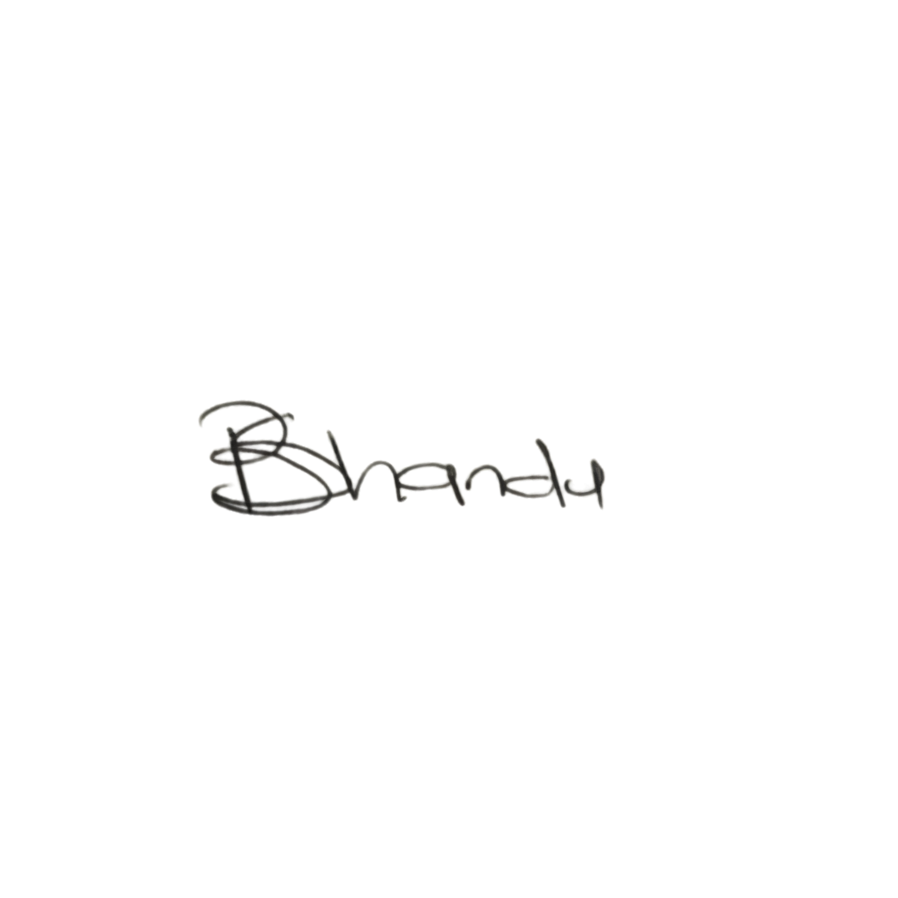  Date: 6 September 2026  Signature copied from supplied signed document | DIRECTOR: ICT AND COMMUNICATIONS  Mr Thapelo Nelson Maqalika  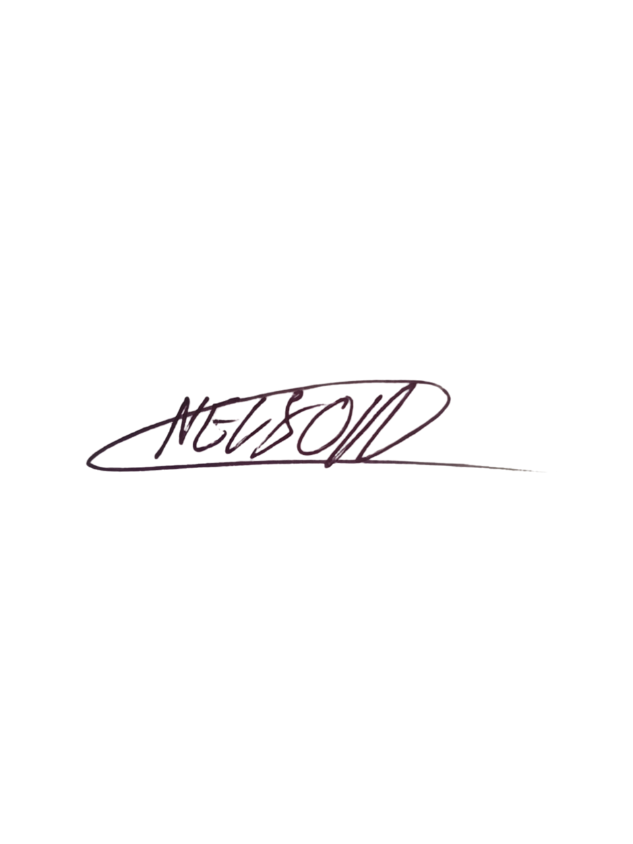  Date: 6 September 2026  Signature copied from supplied signed document
EXECUTIVE DIRECTOR  Mr Bhekisisa Shandu  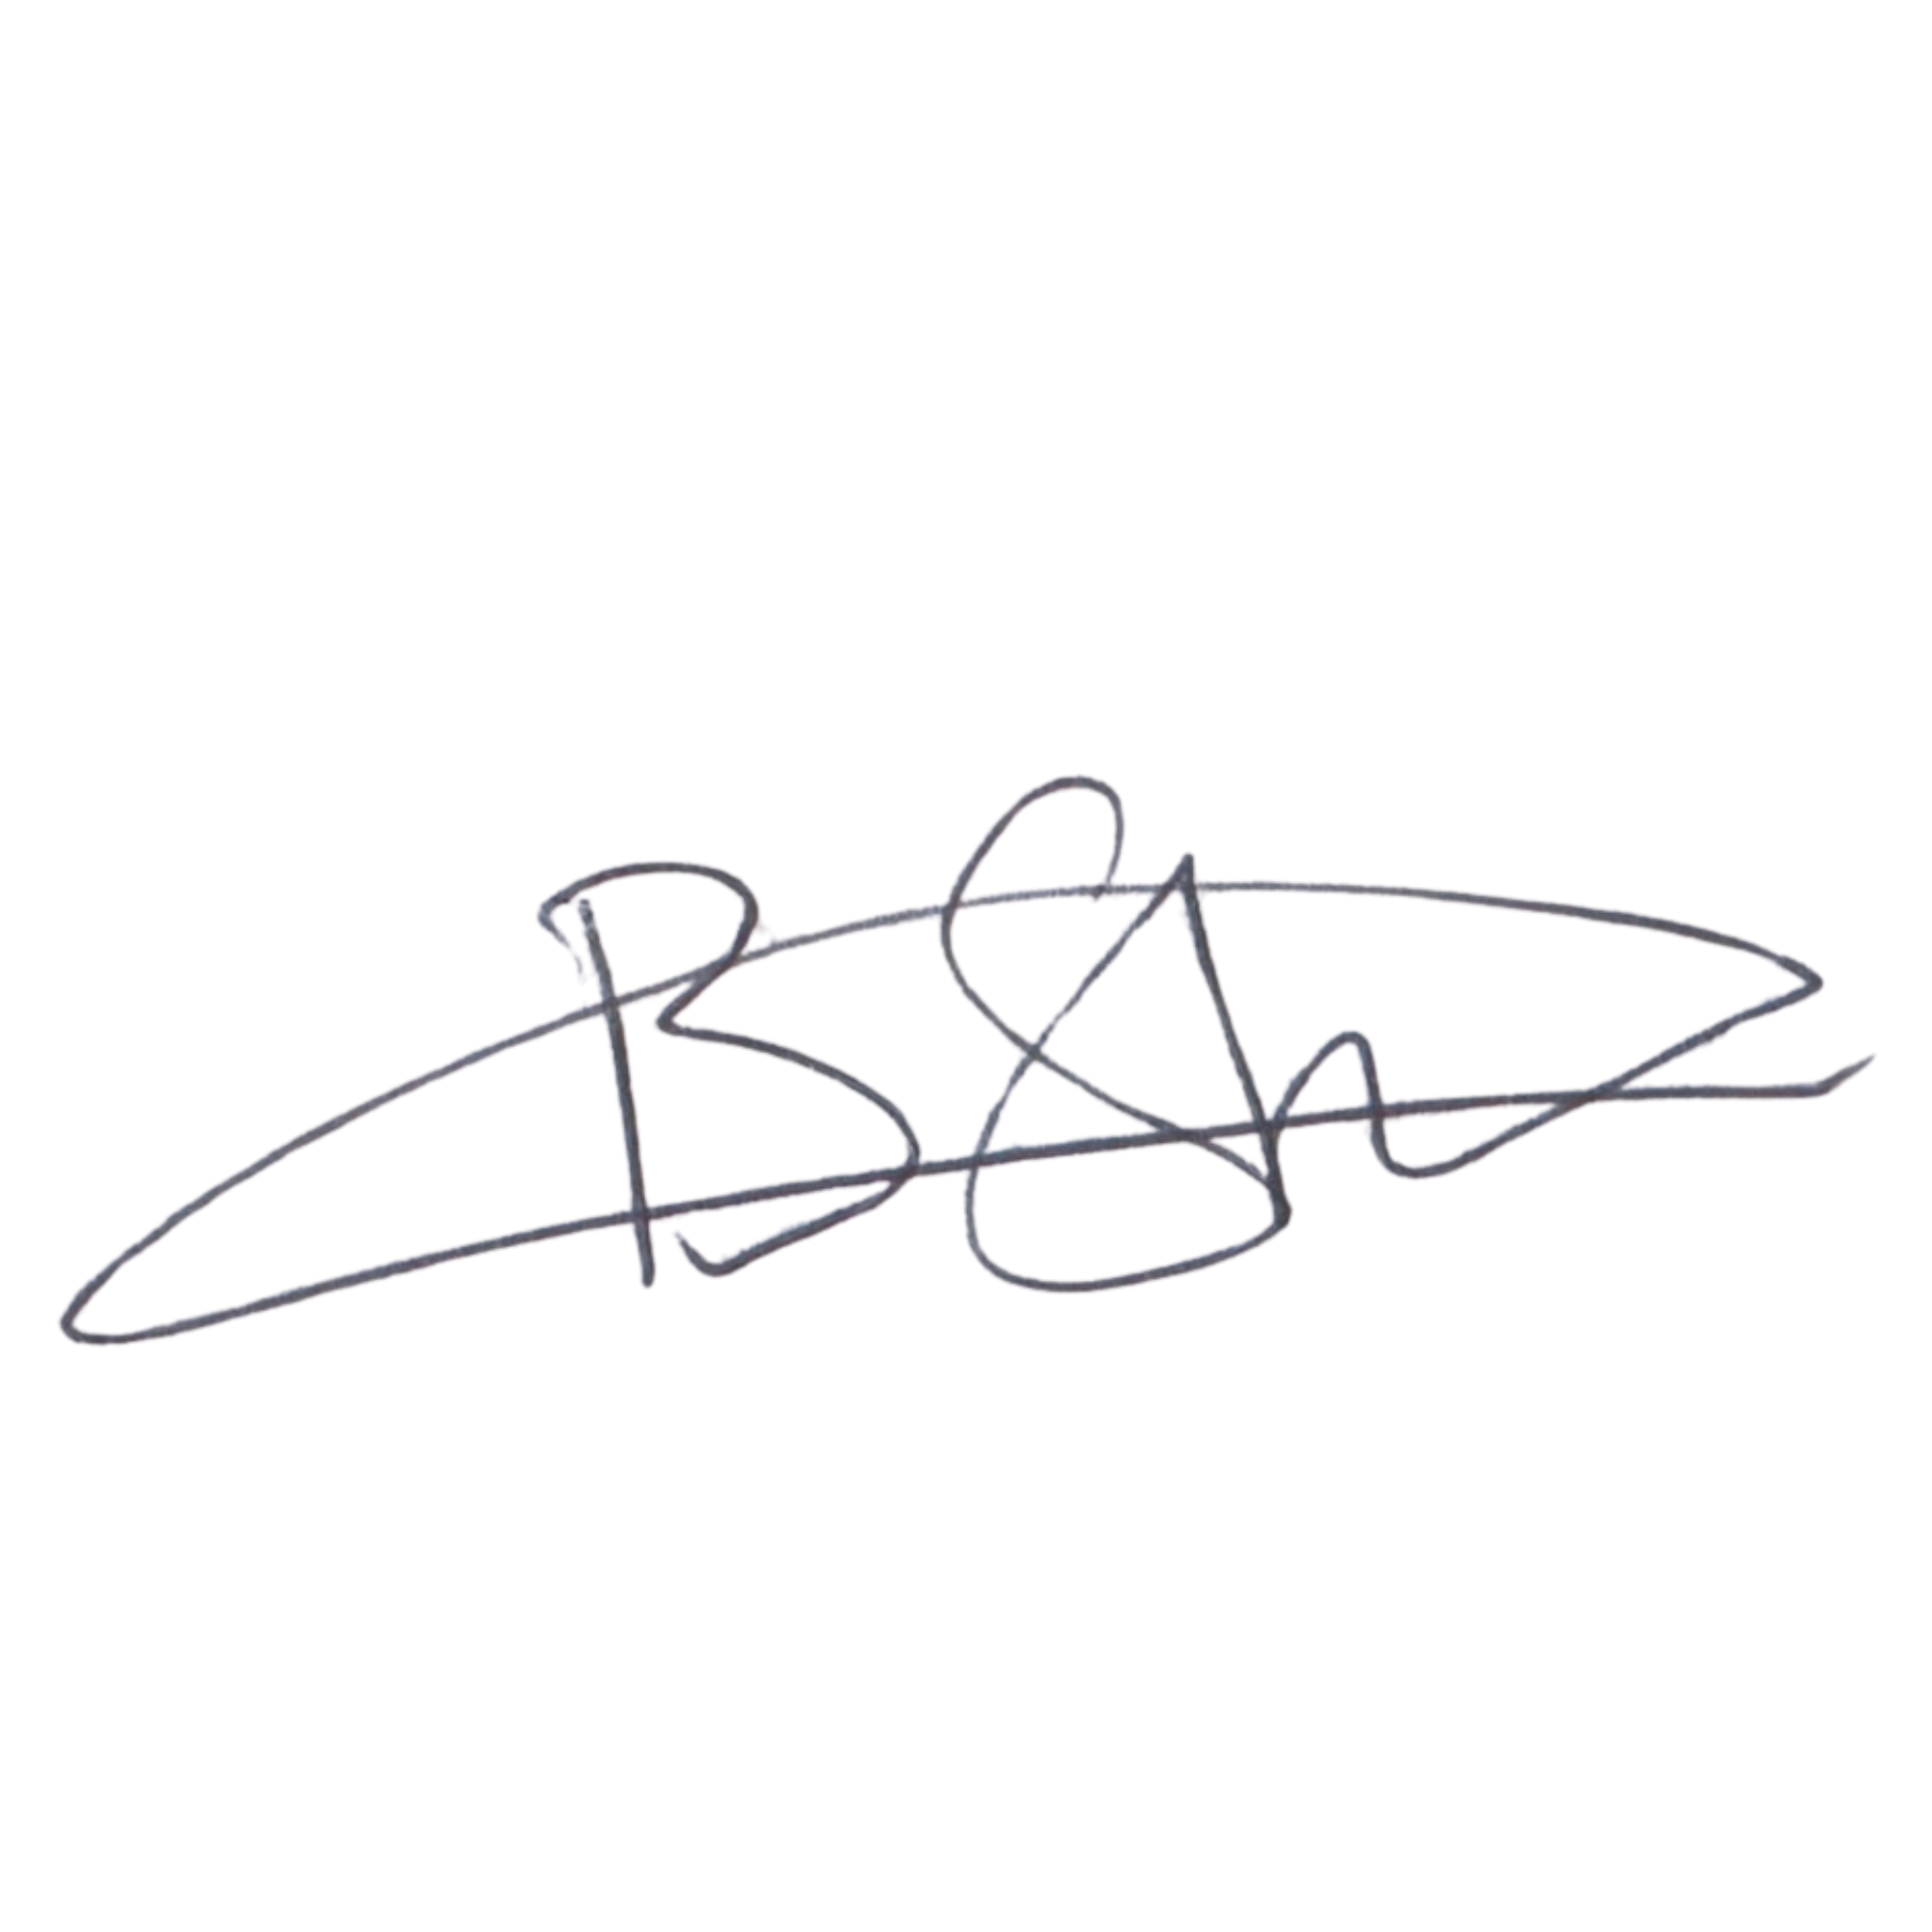  Date: 6 September 2026  Signature copied from supplied signed document | DIRECTOR: PEOPLE AND CULTURE / FINANCE AND PROCUREMENT  Mr Khulekani Gumede  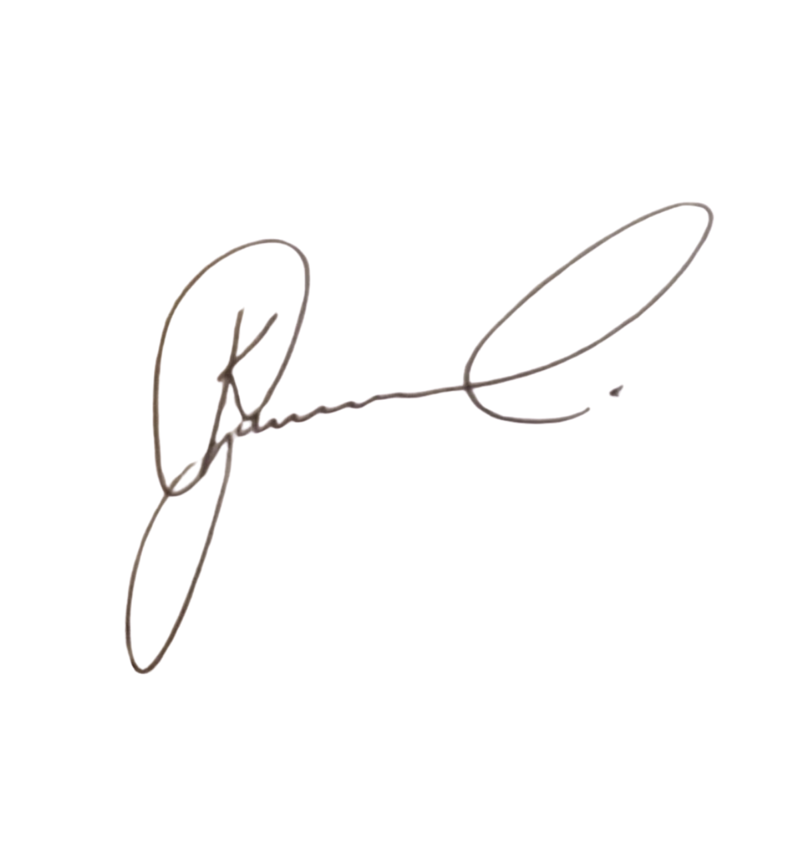  Date: 6 September 2026  Signature copied from supplied signed document

